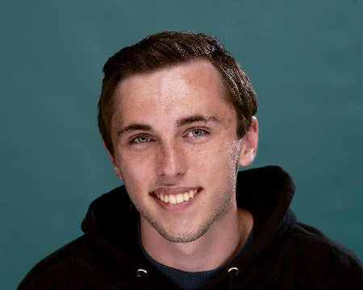**Short Bio:**

I am currently working towards my degree in Computer Science with a concentration in Cyber Security. I have been coding for around 7 years now, starting my first year of high school. I am from Round Rock Texas and graduated high school in 2020 from Round Rock High School. I am planning on graduating from TAMU-CC in 2024.  
**Program and University Selection:**

The small class sizes help me get to know and meet the professors. A lot of my friends who go to bigger universities never meet their teachers while many teachers at this school know my name. This allows me to get noticed and have a better relationship with my learning, as it is more interactive.

**Plans for the Future:**

For my immediate future, I plan on moving up to Maryland because I have a job lined up there after I graduate with the NSA. But I would like to teach one day. I used to be a teacher and teach young kids ages 8-14 how to code through game development, it was SO much fun. However, teaching does not make a lot of sense for me right now, and I would like to return to it sometime in the future.

**Computer Science and Engineering Courses Completed:**

I have completed 7 years of computer Science Courses.

|  |  |
| --- | --- |
| **Computer Languages:**  Java  JavaScript  Python  C++  Lua  HTML | Computer Certifications:  Web Design  Microsoft Excel  Microsoft PowerPoint  TestOut Security  TestOut Networking  TestOut Cyber Defence |

**Expectations From This Course:**

After Taking your previous course Internet Programming, I am hopping to learn more about how my technical skills must mix and connect with social skills to build a strong team and better ready myself for the workforce. I want to learn more modern ways to organize my code, myself, and a team. I loved the hands-on application approach of your last class and I can’t wait to create something I am proud of with a team.

**Expectations From the University and the Program:**

I am hoping that this university will prepare me for the real world and allow me to succeed in pursuing and keeping a job. I would also like the program to help keep my critical thinking skills sharp. I understand I will not go into a job knowing everything, but if I am a critical thinker, I should be able to easily adapt to my new circumstances.